Contents

Q1. 3

Code: 3

Output in file: 4

Output on the terminal: 4

Answer: 4

Q2. 4

Code: 4

Output on terminal: 5

If I use wait in child process: 5

Code: 5

Output in terminal: 6

Q3. 6

Code: 6

Output in terminal: 7

Q4. 7

Output of code: 7

Q5: 7

Code for cost of System call ( fork() ): 8

Output: 9

Code for cost of context switch: 9

Output: 10

# Q1.

## Code:

#include <stdio.h>

#include <stdlib.h>

#include <unistd.h>

#include <fcntl.h>    //for open()

#include <sys/wait.h> //for the wait()

int main(int argc, char *argv[])

{

    // Open the file with O_CREAT to create it if it doesn't exist, O_APPEND  for writing at the end of the file

    int fd = open("q1.txt", O_RDWR | O_CREAT | O_APPEND);

    // checks if file is opened or not, if system call value is -1 then it hasnt opened.

    if (fd < 0)

    {

        printf("Opening file failed, either it doesn't exist or hasn't opened\n");

        return -1;

    }

    int rc = fork();    // creates a new process of the pid

    if (rc < 0)

    {

        printf("Fork Failed\n");

        close(fd); //close the files before exiting

        return -1;

    }

    if (rc == 0)   // Child process

    {

        printf("Child process running and writing in the file\n");

        write(fd, "I am the child process. I am the one writing in the file.\n", 59);

        close(fd); //close the files before exiting

    }

    else   // Parent process

    {

        printf("Parent process running and writing in the file\n");

        write(fd, "I am the parent process. I am the one writing in the file.\n", 60);

        close(fd); //close the files before exiting

    }

    return 0;

}

## Output in file:

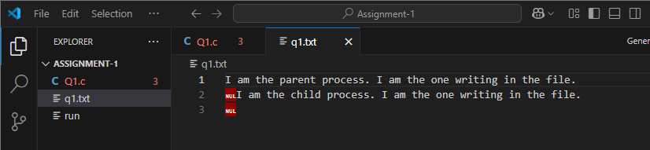

## Output on the terminal:

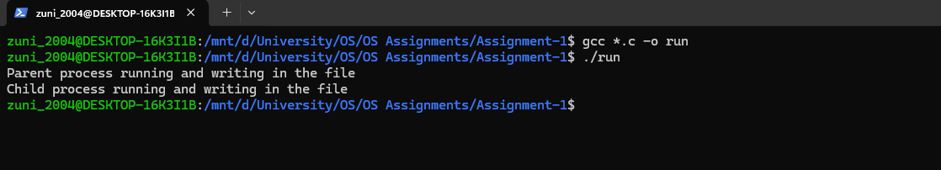

## Answer:

Yes, both the parent and child processes share the same file descriptor. When fork () is called, the child process inherits a copy of the file descriptor table from the parent, meaning they both refer to the same open file description. Even if both the fork processes (child and parent) refer to the same file descriptor, that doesn’t mean they write to the file at the same time because the processes run on at a time because writes do not interfere at the system call level. The order depends on the OS scheduler. If the parent executes first, then the parent’s messages are written first and vice versa if the child executes first. If both processes write at the same time (or almost simultaneously), their output may be interleaved.

# Q2.

## Code:

#include <stdio.h>

#include <stdlib.h>

#include <unistd.h>

#include <sys/wait.h>

int main(int argc, char *argv[])

{

    int pid = getpid(); // the pid of the current running program

    printf("PID is: %d\n", pid);

    int rc = fork(); // created copy of the process

    if (rc < 0)

    {

        printf("Fork Failed\n");

        exit(1);

    }

    if (rc == 0)

    { // Child process

        printf("I am child, pid: %d\n", getpid());

        sleep(2); // for simulating work in child

        printf("Child finished execution\n");

    }

    else

    {                        // Parent process

        int wc = wait(NULL); // for child to finish its execution than parent runs

        printf("Parent here, My pid is %d, Wait system call value is %d\n", getpid(), wc);

    }

    return 0;

}

## Output on terminal:

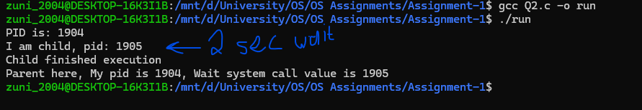

## If I use wait in child process:

The child has no child processes of its own.

Calling wait(NULL); inside the child will fail immediately and return -1.

The parent does not wait for the child because the child does not control the parent's execution.

## Code:

#include <stdio.h>

#include <stdlib.h>

#include <unistd.h>

#include <sys/wait.h>

int main(int argc, char *argv[])

{

    int pid = getpid(); // the pid of the current running program

    printf("PID is: %d\n", pid);

    int rc = fork(); // created copy of the process

    if (rc < 0)

    {

        printf("Fork Failed\n");

        exit(1);

    }

    if (rc == 0)

    { // Child process

        int wc = wait(NULL); // for child to finish its execution than parent runs

        printf("I am child, pid: %d\n", getpid());

        sleep(2); // for simulating work in child

        printf("Child finished execution\n");

    }

    else

    {                        // Parent process

        printf("Parent here, My pid is %d\n", getpid());

    }

    return 0;

}

## Output in terminal:

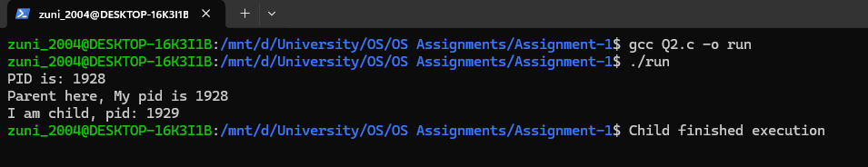

# Q3.

## Code:

#include <stdio.h>

#include <stdlib.h>

#include <unistd.h>

#include <sys/wait.h>

int main(int argc, char *argv[])

{

    int rc;             // to get the fork() system call values for the created new childs

    int pid = getpid(); // the pid of the current running program

    printf("PID is: %d\n", pid);

    for (int i = 1; i <= 3; i++) // for creating three kids

    {

        rc = fork(); // created copy of the parent

        if (rc < 0)

        {

            printf("Fork Failed\n");

            exit(1);

        }

        if (rc == 0)

        {             // Child process

            sleep(i); // for simulating work in child //sleeps 1s more than the previous

            printf("I am child %d, My pid: %d\n", i, getpid());

            exit(0); // exits successfully indicating work is done with no error

        }

    }

    for (int i = i; i <= 3; i++)

    {

        printf("This is parent, waiting for child %d\n", i);

        waitpid(-1, NULL, 0); // waitimg for any child to finish

    }

    printf("All three children finished working. Parent exiting.\n");

    return 0;

}

## Output in terminal:

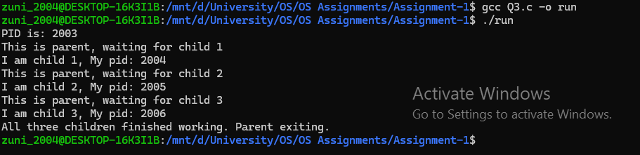

# Q4.

## Output of code:

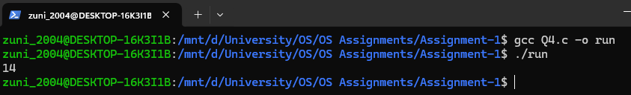

* Create a Pipe: pipe(pipefd) creates two endpoints: one for reading (pipefd[0]) and one for writing (pipefd[1]).
* First Child Process (child1):
  + Forks a child process.
  + Closes the read end of the pipe.
  + Redirects its output to the write end: dup2(pipefd[1], STDOUT_FILENO).
  + Executes execlp("echo", "echo", "Hello, world!", NULL), writing "Hello, world!" into the pipe.
* Second Child Process (child2):
  + Forks another child.
  + Closes the write end of the pipe.
  + Redirects its input to the read end: dup2(pipefd[0], STDIN_FILENO).
  + Executes execlp("wc", "wc", "-c", NULL) to count characters from the pipe.
* Parent Process:
* Closes both ends of the pipe.
* Waits for both children to finish.

The first child writes "Hello, world!" (14 characters) to the pipe, and the second child counts those characters, returning 14.

# Q5:

## Code for cost of System call ( fork() ):

#include <stdio.h>

#include <stdlib.h>

#include <unistd.h>

#include <sys/types.h>

#include <sys/wait.h>

#include <sys/time.h>

int main()

{

    struct timeval start;     // To store start time

    struct timeval end;       // To store end time

    long total_fork_time = 0; // To store total time for fork() calls

    // Measure timer overhead (cost of calling gettimeofday() multiple times)

    long avg_timer_overhead = 0;

    for (int i = 0; i < 1000000; i++) // Repeat 1,000,000 times for accuracy

    {

        gettimeofday(&start, NULL); // Start time

        gettimeofday(&end, NULL);   // endd time

        // Calculate time taken by gettimeofday() itself

        avg_timer_overhead = avg_timer_overhead + ((end.tv_sec - start.tv_sec) * 1000000 + (end.tv_usec - start.tv_usec));

    }

    avg_timer_overhead = avg_timer_overhead / 1000000; // Get average overhead

    // Measure fork() cost

    gettimeofday(&start, NULL);   // Start time before creating child processes

    for (int i = 0; i < 100; i++) // Loop to create 100 child processes

    {

        int rc = fork();

        if (rc < 0)

        {

            _exit(1); // Exit the program with an error code

        }

        if (rc == 0) // Child process

        {

            _exit(0); // Child exits immediately

        }

        else if (rc > 0) // parent process

        {

            wait(NULL); // waiting for child to finish

        }

    }

    gettimeofday(&end, NULL); // time end

    // Calculate total time taken for all fork() calls

    total_fork_time = (end.tv_sec - start.tv_sec) * 1000000 + (end.tv_usec - start.tv_usec);

    // Subtract timer overhead for more accurate fork() measurement

    total_fork_time -= avg_timer_overhead * 100;

    // Estimate cost per fork()

    double cost_per_fork = (double)total_fork_time / 100;

    // Calculate and display total cost and cost per fork()

    printf("Total cost for 100 fork() calls: %ld microseconds\n", total_fork_time);

    printf("Estimated cost per fork(): %.2f microseconds\n", cost_per_fork);

    return 0;

}

## Output:

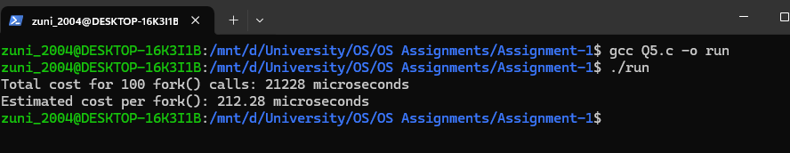

## Code for cost of context switch:

#include <stdio.h>

#include <stdlib.h>

#include <unistd.h>

#include <sys/types.h>

#include <sys/wait.h>

#include <sys/time.h>

#include <sched.h>

int main()

{

    int pipe0[2]; // Pipe for communication from parent to child

    int pipe1[2]; // Pipe for communication from child to parent

    struct timeval start;

    struct timeval end; // Variables to store start and end times

    int rc;

    // Create pipes

    if (pipe(pipe0) == -1 || pipe(pipe1) == -1)

    {

        printf("pipe failed");

        exit(1);

    }

// Giving me error so i am unable to use the CPU Affinity so I commented out

    // cpu_set_t mask;

    // int cpu = 0; // Set affinity to CPU 0

    // CPU_ZERO(&mask);

    // CPU_SET(cpu, &mask);

    // sched_setaffinity(0, sizeof(mask), &mask); // Bind to CPU 0

    // Create child process

    rc = fork();

    if (rc < 0)

    {

        printf("fork failed");

        exit(1); // exit woth error

    }

    if (rc == 0)

    { // Child process

        // Close unused pipe ends

        close(pipe0[1]); // Close write end of pipe0

        close(pipe1[0]); // Close read end of pipe1

        char buf;

        gettimeofday(&start, NULL); // Start time for child process

        for (int i = 0; i < 1000000; i++)

        {

            // Write to pipe0

            write(pipe0[1], "x", 1);

            // Read from pipe1

            read(pipe1[0], &buf, 1);

        }

        gettimeofday(&end, NULL); // End time for child process

        close(pipe0[0]);          // Close read end of pipe0

        close(pipe1[1]);          // Close write end of pipe1

        // Calculate total time taken for context switches

        long total_time = (end.tv_sec - start.tv_sec) * 1000000 + (end.tv_usec - start.tv_usec);

        printf("Child total time for %d iterations: %ld microseconds\n", 1000000, total_time);

        exit(0); // Exit child process

    }

    else

    { // Parent process

        // Close unused pipe ends

        close(pipe0[0]); // Close read end of pipe0

        close(pipe1[1]); // Close write end of pipe1

        char buf;

        gettimeofday(&start, NULL); // Start time for parent process

        for (int i = 0; i < 1000000; i++)

        {

            // Read from pipe0

            read(pipe0[0], &buf, 1);

            // Write to pipe1

            write(pipe1[1], "x", 1);

        }

        gettimeofday(&end, NULL); // End time for parent process

        close(pipe0[1]);          // Close write end of pipe0

        close(pipe1[0]);          // Close read end of pipe1

        // Wait for the child process to finish

        wait(NULL);

        // Calculate total time taken for context switches

        long total_time = (end.tv_sec - start.tv_sec) * 1000000 + (end.tv_usec - start.tv_usec);

        printf("Parent total time for %d iterations: %ld microseconds\n", 1000000, total_time);

    }

    return 0; // Exit successfully

}

## Output:

